# Preprocessing step

* To run the optimization for all countries provided in the ECDC data file, open Matlab and run calc_all_countries.m
* Choose whether to run the optimization for an existing file, or load last updated data from ECDC

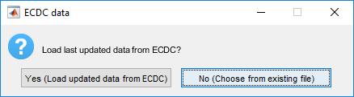

# Gui

* After the preprocessing step finishes, run the GUI (gui.m)

**Important note: the optimization for all 210 countries takes approximately 24 hours**

**The current mat files already contains preprocessing step for data taken from ECDC at September 2020. You can skip preprocessing step and run the GUI to get prediction made at September 2020.**